**September 26, 2019**

**Group Leader**

**Name:** Inam Gul

**Roll No:** 16K-3607

**Group Member**

**Name:** Muhammad Bilal Ashfaq

**Roll No:** 16K-3636

**Group Member**

**Name:** Syed Ammar Mahmood

**Roll No:** 16K-3629



Final Year Project

|  |
| --- |
| **_______________________** |
| **Supervisor**  **Mr. Farrukh Hasan** |



Table of Contents

1. Motivation 0

2. Overview 0

2.1. Significance of the Project 0

2.2. Description of the Project 0

2.3. Background of the Project 1

2.3.1. Geo-Fencing 1

2.3.2. Geo-Targeting: 1

2.3.3. Geo-Conquesting 1

2.3.4. Beacons-Technology 1

2.3.5. CURRENT APPLICATIONS IMPLEMENTING LOCATION BASED MARKETING 2

2.4. Project Category 2

3. Features: 3

4. Project Planning 4

4.1. Methodology 4

4.1.1. Iterative Model 4

4.2. Architecture 5

4.2.1. Repository Architecture 5

4.2.2. Client Server Architecture 5

5. Project Feasibility 7

5.1. Technical Feasibility 7

5.2. Economic Feasibility 7

5.3. Schedule Feasibility 8

5.3.1. Gantt Chart: 8

5.3.2. Work Breakdown Structure: 8

6. Hardware and Software Requirements 9

6.1. Hardware Requirements: 9

6.2. Software Requirements: 9

7. Representation of the Overall System 9

8. References 9

# Motivation

In this age of globalization everyone needs to be aware of events occurring around them and tech minds are working on ways to provide quick and effective information to people with less hassle. If we talk about businesses nowadays, the success of their business and popularity of their products is highly dependent on promotional activities. So, every vendor nowadays is looking for efficient ways for promoting their products. As we are moving ahead in this age of technology new inventions are being made and technology is becoming easily accessible to everyone. So, taking advantage of this point, this FYP is motivated to bring modernity and efficiency in marketing techniques used nowadays. We are working on context-based marketing which will target specific people based on their location.

# Overview

# Significance of the Project

If we have a look on marketing strategies nowadays, although they are much effective and provide required results but on the other hand these marketing strategies irritates customer at some point. Like if we take one strategy which is commonly used nowadays is that brands save the customers data and when they want to convey any notification to their customers they push message to all customers in their database irrespective of whether it is in the interest of that particular person or not, thus creating spam message. Another technique used is to through advertisements on different social websites which sometimes create irritation to user.

The major advantage of our product is reduced ratio of spam messages. We will be targeting specific people inside certain geo location thus reducing the factor of spamming. Secondly this app can be used by government bodies, blood banks, etc. to update people about any emergency or any other scenario. We are trying to implement some efficient marketing strategies implemented by some vendors in different scenarios individually, in one project. Thus, a compact marketing package will be seen after completion of this project.

# Description of the Project

Our project is based on pillars of location-based marketing. As we can see several applications are being made that are implementing some aspects of location-based marketing but our focus is to provide maximum ease to our clients by integrating all the basic functionalities that are needed for location-based marketing. Our primary goal is to implement a notifying system that will through any message to a person based on its location. We will also be implementing some filters and portion which will facilitate user to browse deals and other stuff a brand of their Interest. Our application will be divided into three parts l-e vendors, users and providers. Companies or the one who are willing to do marketing from our portal are called as vendors, users are our app users who will be getting promotions and deals regarding their respective brands, and providers are admins who will maintain the project

# Background of the Project

As far as location-based marketing is concerned there are four main pillars that lay down platform for this marketing strategy. These components are discussed below:

# Geo-Fencing

It is location-based advertisement technique in which user’s location is watched and only people in specific location target are notified. The targeted users use any applications or participate in any programs where they are prompted to enter their location or allow a web service to access their location.

Facebook and Google (Google AdWords) has provided this feature to their user, to create a geo fence and notify about anything to your targeted audience **[1][4]**.

# Geo-Targeting:

The practice of delivering content/advertisements to people based on their geographic location is termed as geo-targeting. Google Ads (formerly known as AdWords) has a feature that allows search advertisers to specify a location, or a set of locations, as the only area(s) in which they want their ads to show.

This technique facilitates those restaurants and markets that have branches in different areas and they want to notify only people of that particular area. This saves people from a lot of spamming and cost of advertiser is also reduced **[4]**.

# Geo-Conquesting

This idea is somehow close to above to mentioned techniques. The core idea of this technique is to direct potential customers to your business when they are close to your competitors. This technique is used to increase brand awareness and attract customers towards your shop from your competitors. For example, if you are an independent coffee shop, you could introduce geo conquesting to your marketing plans by targeting users who are at nearby big chains like Starbucks or Costa with ads about the great menu items you offer, cheaper coffee, fantastic loyalty scheme or the importance of supporting small, local, independent businesses **[2][4]**.

# Beacons-Technology

This technique is used at lower level to market products individually. The core idea behind this technique is when customer passes by any product in shop the wireless transmitters notify him about any special packages offered by that shop on that product. This technique is considered to be latest development in proximity marketing **[3][4]**.

# CURRENT APPLICATIONS IMPLEMENTING LOCATION BASED MARKETING

* + - 1. **PEEKABOO GURU**

Peekaboo Guru app provides you best deals & discounts on top brands, restaurants & bars currently available You can select your city and app will let you know about all deals and discounts available in that city on all top brands. (geo targeting)

* + - 1. **Save Yours**

Save Yours is an application perfectly made for all foodies.it implement geo targeting by displaying all deals and discounts on food brands in particular city.

# Project Category

It is a product-based project.

# Features:

This project provides location-based marketing depending on customer choice. This app provides easy access to the brands new deals that connect customers on the bases of their location. This will provide the information of best places nearby along with the best deals. The Company and Consumer relationship will be maintained by maintaining rewards points.

* **Main Significant Feature**

Main feature and the motivation of making our project is that, it can be used in various contexts not for only marketing. Like announcements in targeted areas etc. other than that, it will completely modernize the ways of marketing too.

* **Other features are**
* Can create push notification for targeted audience
* Can add more members of their marketing team as well as their dashboard
* Can settle down all the permissions for their own members.
* Can view their limit reaching the purchased amount like push messages will be allowed 10,000 in one month at some price, and 20,000 for more price etc. (Different packages)
* Have access to stop the push notification created from any company.
* Have rights to take a decision for clash of same marketing place
* Can block any user in case of security threads
* Increase or decrease the area of changing location
* Can access the personal data of users of better experience and personalized suggestion
* Have a threshold marketing deal that every company should stay on their limit of offering
* Location update via backend service
* Search option for the best options in any categories (like restaurants, shops, market etc.) nearest to customer.

# Project Planning

# Methodology

# Iterative Model

In Iterative model, major Requirements for the complete system is must defined however minor requirement like some functionality or requested enhance feature may add according to time. The new technology is being used will learnt by the development team while working on the project.



* + - 1. **Advantages of Iterative Model:**
* In this model requirements are flexible
* In each Project cycle, result is obtained
* Risk analysis will be better
* Program will be Verified and Maintained
* By using this architecture customer will facilitate and easily evaluate and give their feedback
  + - 1. **Reason for using Iterative Model:**

We are using Iterative Model because minor requirements will be added time to time after each iteration, we analyze the design change, implement that requirement, test that requirement and maintain that development

# Architecture

Hybrid Architecture is used for increasing flexibility and efficiency.

# Repository Architecture

Android Application and Web Application both must exchange data in real time. This may be done by using Repository Architecture. Repository Architecture will be the shared part between two servers used by our project team.

Each Application maintain own database and passes data explicitly to each other and will be responsible for changes on the other hand too, so that synchronization will be take place.

* + - 1. **Advantages of Repository Architecture**
* Efficient way to share large amounts of data
* Centralized Management that take control of backup, integrity and security
* Integrate to different database and maintain the workflow

# Client Server Architecture

Data processing is distributed across multiple clients and Application Servers and also allows client to access server from any point of connection, and privilege levels will be maintained at server level so that data can be confidential and secure.

* + - 1. **Advantages of Client Server Architecture**
* Organize the Client and server in set of layers each provide set of services
* Data Encryption attain successfully
* Message broadcast will be easy through server
  + - 1. **Diagram Client and Server + Repository Architecture:**



# Project Feasibility

# Technical Feasibility

* Technology used for the project is highly maintainable, so that will not affect the project
* Risks
  + Cost/ Time Overruns: This is Final Year Project, so we have a lot of time to make it possible to work efficiently
  + Benefits retain: Project will target a lot of peoples as well as brands and companies that are willing to advertise their context, so from this point of view, it is good in its way.

# Economic Feasibility

Tools that are used in this project are

1. Firebase

Initially, Firebase don’t change any amount means that during the whole development, we will not get any problems with it. After deployment, when we will exceed the limits, they will charge us based on our demand. Which is highly economic. Like Firebase Cloud Firestore charges $0.18/GB, which is economically affordable

1. Android Studio (Java)

Android Studio is the official integrated development environment for Google's Android operating system. They are not charging any amount on developers.

1. Visual Studio (ASP.NET)

Visual Studio is a good platform for ASP.NET development. ASP.NET is an open-source server-side web application framework designed for web development to produce dynamic web pages developed by Microsoft to allow programmers to build dynamic web sites, applications and services. They have some license issues but are economically good when it comes in development which is quite better than other platforms

1. Microsoft SQL Server

Microsoft SQL Server is a relational database management system developed by Microsoft. As a database server, it is a software product with the primary function of storing and retrieving data as requested by other software applications. Using Microsoft server is also a good choice because of its features provided before deployment

# Schedule Feasibility

# Gantt Chart:

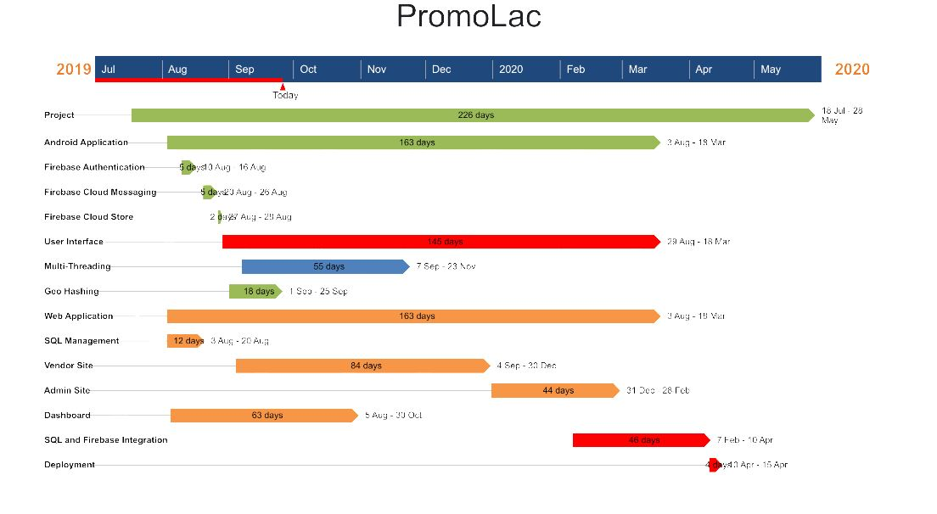

# Work Breakdown Structure:

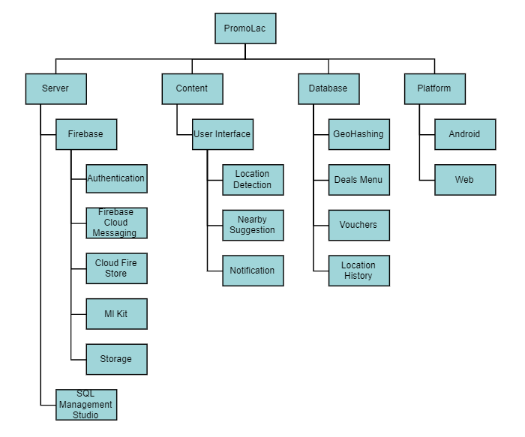

# Hardware and Software Requirements

# Hardware Requirements:

* Processor: Intel Core i5 6 generation and above
* Memory: 8 GB and above
* Storage: 120 GB and above (SSD will be preferable)

# Software Requirements:

OS: 64-bit Windows 7/10

Software: JDK, Android Studio, Visual Studio, Oracle VMware, SQL Server 2017, Anaconda Distribution

# Representation of the Overall System



# References

**[1]** Seth WINTERER, “What is Geofencing Marketing?”, MAY 8, 2018.

**[2]**  [Kendra Woodruff](https://trafficoxygen.com/author/kendratrafficoxygen-com/), “GeoConquesting“, February 13, 2019.

**[3]** Lauryn Chamberlain, “GeoMarketing 101: What Is Geotargeting?”, Mar 31, 2016

**[4]** Brian Handly, “Getting back to basics with location-based marketing”, February 7, 2019